**Subhan Bin Yousaf**

**Section B**

**481281**

**FOP Lab Manual 5**

**Lab Tasks**

**Lab Task 1 :**

#include <iostream>

using namespace std;

int main() {

int x=1;

do{

cout<<"enter a number "<<endl;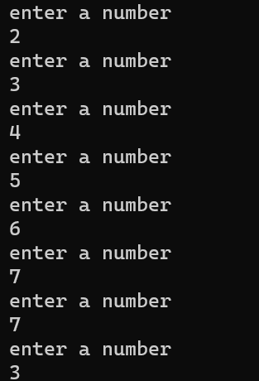

cin>>x;

}

while(x>0);

return 0;

}

**Lab Task 2 :**

#include <iostream>

#include <math.h>

using namespace std;

int main() {

int a,b,i;

double c;

char d;

do{

cout<<"Enter the first number "<<endl;

cin>>a;

cout<<"Enter the second number "<<endl;

cin>>b;

cout<<"Select Operation +,-,/,*,%,^"<<endl;

cin>>d;

switch(d){

case '+':

c=a+b;

break;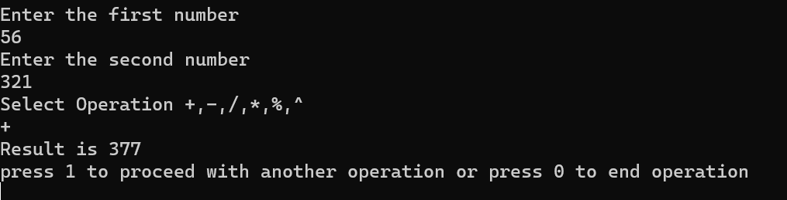

case '-':

c=a-b;

break;

case '*':

c=a*b;

break;

case '/':

c=a/b;

break;

case '%':

c=a%b;

break;

case '^':

c=pow(a,b);

break;

}

cout<<"Result is "<< c<<endl;

cout<<"press 1 to proceed with another operation or press 0 to end operation"<<endl;

cin>>i;

}

while(i==1);

return 0;

}

**Lab Task 3A :**

#include <iostream>

using namespace std;

int main() {

int sum,a=2;

do {

sum=sum+a;

a+=2;

}

while(a<=100);

cout<<"The sum of the first 50 even numbers are "<< sum <<endl;

return 0;

}



**Lab Task 3B :**

#include <iostream>

using namespace std;

int main() {

int sum=0,a=1,b;

do {

b=a*a;

a+=1;

sum=sum+b;

}

while(a<=100);

cout<<"The sum of all squares between 1 and 100 is "<< sum<< endl;

return 0;

}



**Lab Task 4A :** 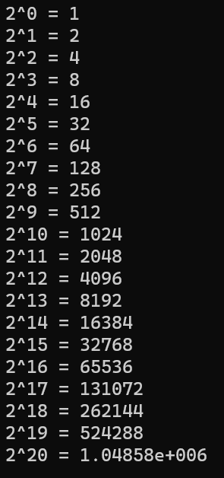

#include <iostream>

using namespace std;

#include <math.h>

int main() {

int a=0;

do{

cout<<"2"<<"^"<< a <<" = "<< pow(2,a)<<endl;

a++;

}

while(a<=20);

return 0;

}

**Lab Task 4B :**

#include <iostream>

using namespace std;

int main() {

int a,b,sum;

cout<<"Input Interval"<<endl;

cin>>a;

cin>>b;

if (a%2==0) {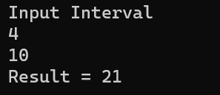

a+=1;

}

do{

sum=sum+a;

a+=2;

}

while(a<=b);

cout<<"Result = "<< sum <<endl;

return 0;

}